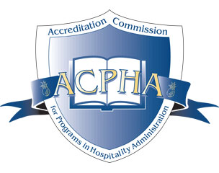
ACPHA

ELIGIBILITY REQUIREMENTS FOR PROGRAMS SEEKING ACCREDITED STATUS

Each program applying for affiliation with the Accreditation Commission must initially demonstrate that it satisfies each of the requirements listed below. Taken together, these requirements define the kind of program that the Commission considers a part of its educational universe and within the scope of the accrediting activities for which it assumes responsibility.

The program:

- must be part of an educational institution accredited by a regional or national accrediting body recognized by the U.S. Secretary of Education. An international program must part of a recognized National/Government accrediting agency in that country

2. has a statement of mission and objectives appropriate to a postsecondary program

3. offers postsecondary educational instruction leading to an associate or baccalaureate degree (or their equivalents) in hospitality administration

4. must have institutional approval for courses and degree(s) offered

5. has a formally designated director (or the equivalent) of the program

6. has been in continuous operation for at least four years and has had at least three years of graduating classes by the time of review

7. has a teaching faculty assigned to the program

8. makes freely available to all interested persons (and especially to its potential and enrolled students) an accurate, fair, and substantially complete description of its program and related activities, policies, and procedures

9. admits students under policies and procedures that are appropriate to the program and does not discriminate with respect to age, sex, ethnic background, race, creed, or disability

Accreditation Commission for Programs in Hospitality Administration
P.O. Box 400 • Oxford, MD 21654
Email: acpha@atlanticbb.net • Phone: 410.226.5527

